

Ducklings Information

Our aim for the babies and their parent & carers is initially to help settle into their new environment, forge a bond with key-person and gradually, once child is settled and ready to explore their new environment we will provide a balanced day with a variety of stimulating activities suitable for their age and personal development.

We welcome parents to stay and play and to spend time in the room getting to know the staff and the environment, you will feel more confident when leaving your child and if your child has had some visits they will settle more quickly.
Ideally, we like to have at least three visits before they start with us, if you feel your child needs more then we can arrange this.
All children are unique and will have different needs to help them settle.
We will do our best to support you and your child with this important transition into the Nursery environment.

Duckling’s room has a staff ratio of 1 to 3 children, on occasion we have additional help from students, extra staff also cover over the lunch period to ensure staff/child ratios are always met.

The room is set out so that babies have easy access to all areas to allow for continuous play in the room.
The area are enhanced by providing additional play activities, for example foam/sand/water play (Adult oversees play).
We provide larger apparatus like the climbing frame to help develop large motor skills to aid with crawling and walking.
Some activities are adult led which include, arts and crafts, music and singing sessions and treasure basket / heuristic play.

As the child’s main carer and educator any comments you share with us will be very helpful, please share your child’s achievements with us and feel free to comment on your child’s personal learning. You can add comments to the parent-zone app or tell us and we will happily add information.
The more you share with us the better we can support you and your child.

Observations are carried out by the key-person; this is to make sure we are meeting children’s individual needs; they will work closely with you to ensure your happy with the care we provide acting as point of contact with parents.
Please speak to your child’s key-person and they will be happy to share their findings with you and discuss if you have any concerns.

The room is managed by two senior members of staff (job share) and by full time staff, all of who are fully qualified practitioners and will be happy to speak to you about any concerns you may have or please speak to office staff who will be more then happy to help.

We have access to a small covered garden area and we have buggies to take the babies out for walks in the local area and parks or to feed the ducks.
Weather permitting, we aim to take each child outside for some fresh air on daily basis.

Basic routine:

The children are greeted on arrival and are offered breakfast or morning snack depending on their needs at approx 8.30

The routine ‘s of individual children is met whenever possible to enable continuity of care.
Nappies are changed as and when needed or as part of daily routine usually three times a day.

Cooked lunch is served at 12.30. however, we will try and accommodate individual routines as much as possible.

Mid afternoon snack, supplied by nursery

Things to remember to bring in for your child’s first day:

- Provide a written basic routine of your child’s day or you can write on
‘All About Me’ sheet
- Cup/beaker/bottle for water that can stay here. These will be sterilised each day.
- If your baby is on formula milk please provide cartons or please measure up powdered formula into an individual container clearly saying how much water needs to be added.
- Lunch if not eating nursery dinner.
- Nappies – Wipes - Nappy cream -Change of clothes - Comforters if needed.
- Sun-cream and Sunhat in warmer weather

- Photo of child and parents/carers, these are used to display in the room so that the child can see them.
- Medications (paracetamol/ibuprofen)
Please label all items clearly; this saves lots of confusion at the end of the day.
Please feel free to talk to staff within the room whenever you have any questions or queries, or if you have any suggestions/ideas you may wish to pass on to us.
Additional Information
A peg and bag area will be provided for you to place your child’s personal belongings on. No plastic bags please.

Please make sure all forms are completed by your child’s first day ~ and keep us up dated on new contact details as they change or send request to change details on Parent-zone app.

On arrival, you are more than welcome to settle your child in or pop in for a play and catch up with staff before you leave ~ we just ask you to remove shoes or pop on shoe covers before you enter the room.
Covers are kept by door entrance.
We hold parental meetings so you can discuss your child’s development and share information this is normally done in the evening out of nursery hours, however if this is difficult we can make alternative arrangements.
When it is time for your baby to move up into the next room, the key-person will help them to settle by taking them for visits, usually for about a month prior to their move but if necessary they can be arranged over a longer period depending on individual needs.
You will be informed when this happens and will be introduced to new staff.

Ducklings Staff
Senior Early Years Practitioner Early Years Practitioner
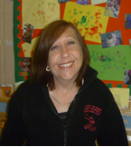


Karen Hards Annabel Belfield

Early Years Practitioners
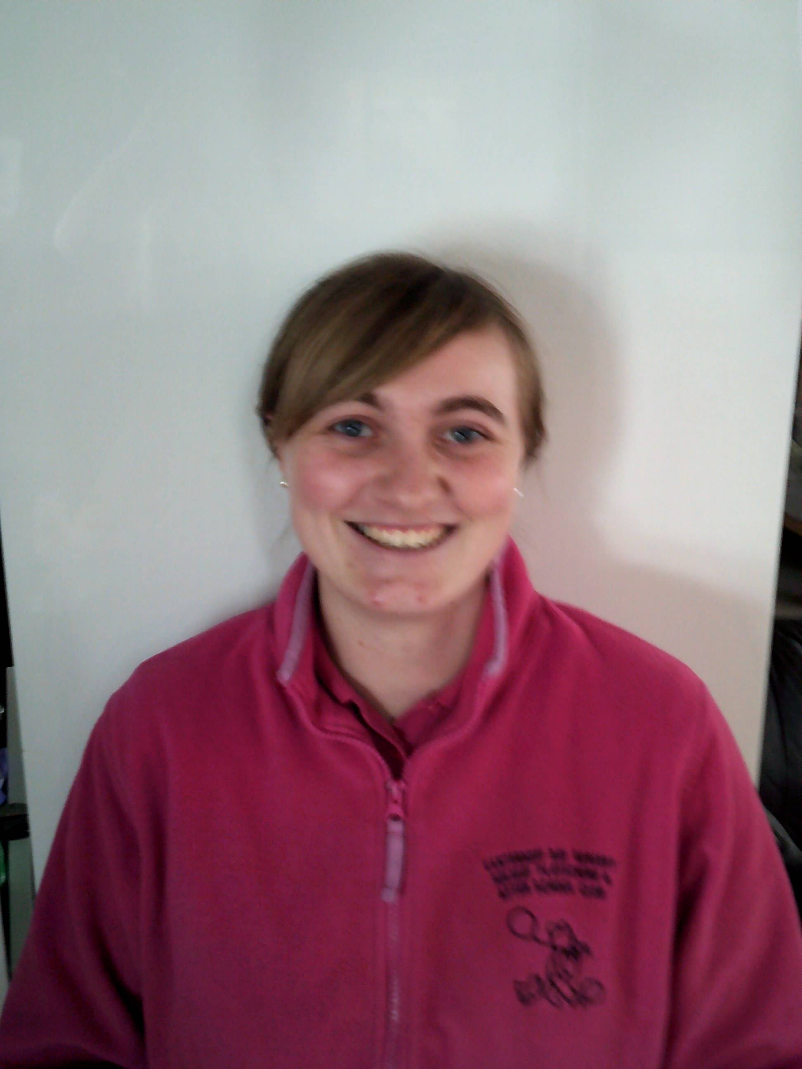
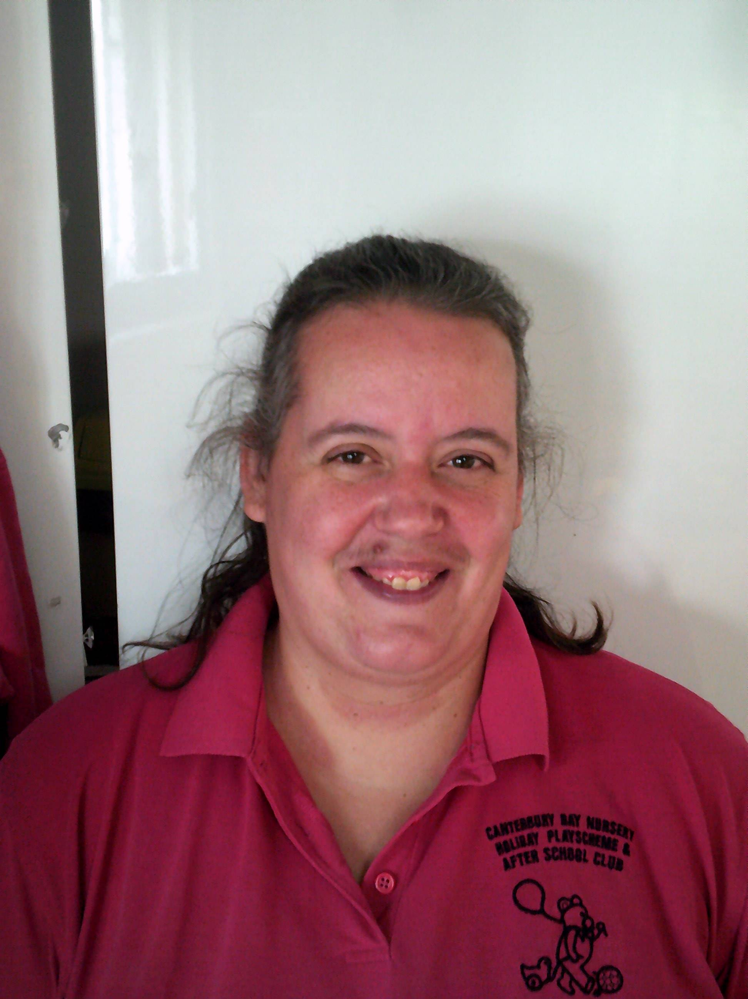

Hannah Phipps Rosie Argent-Paine Jessica Roberts

Early Years Practitioners Cover Staff


Megan Pearce Corina Jones
Lunchtime Assistant
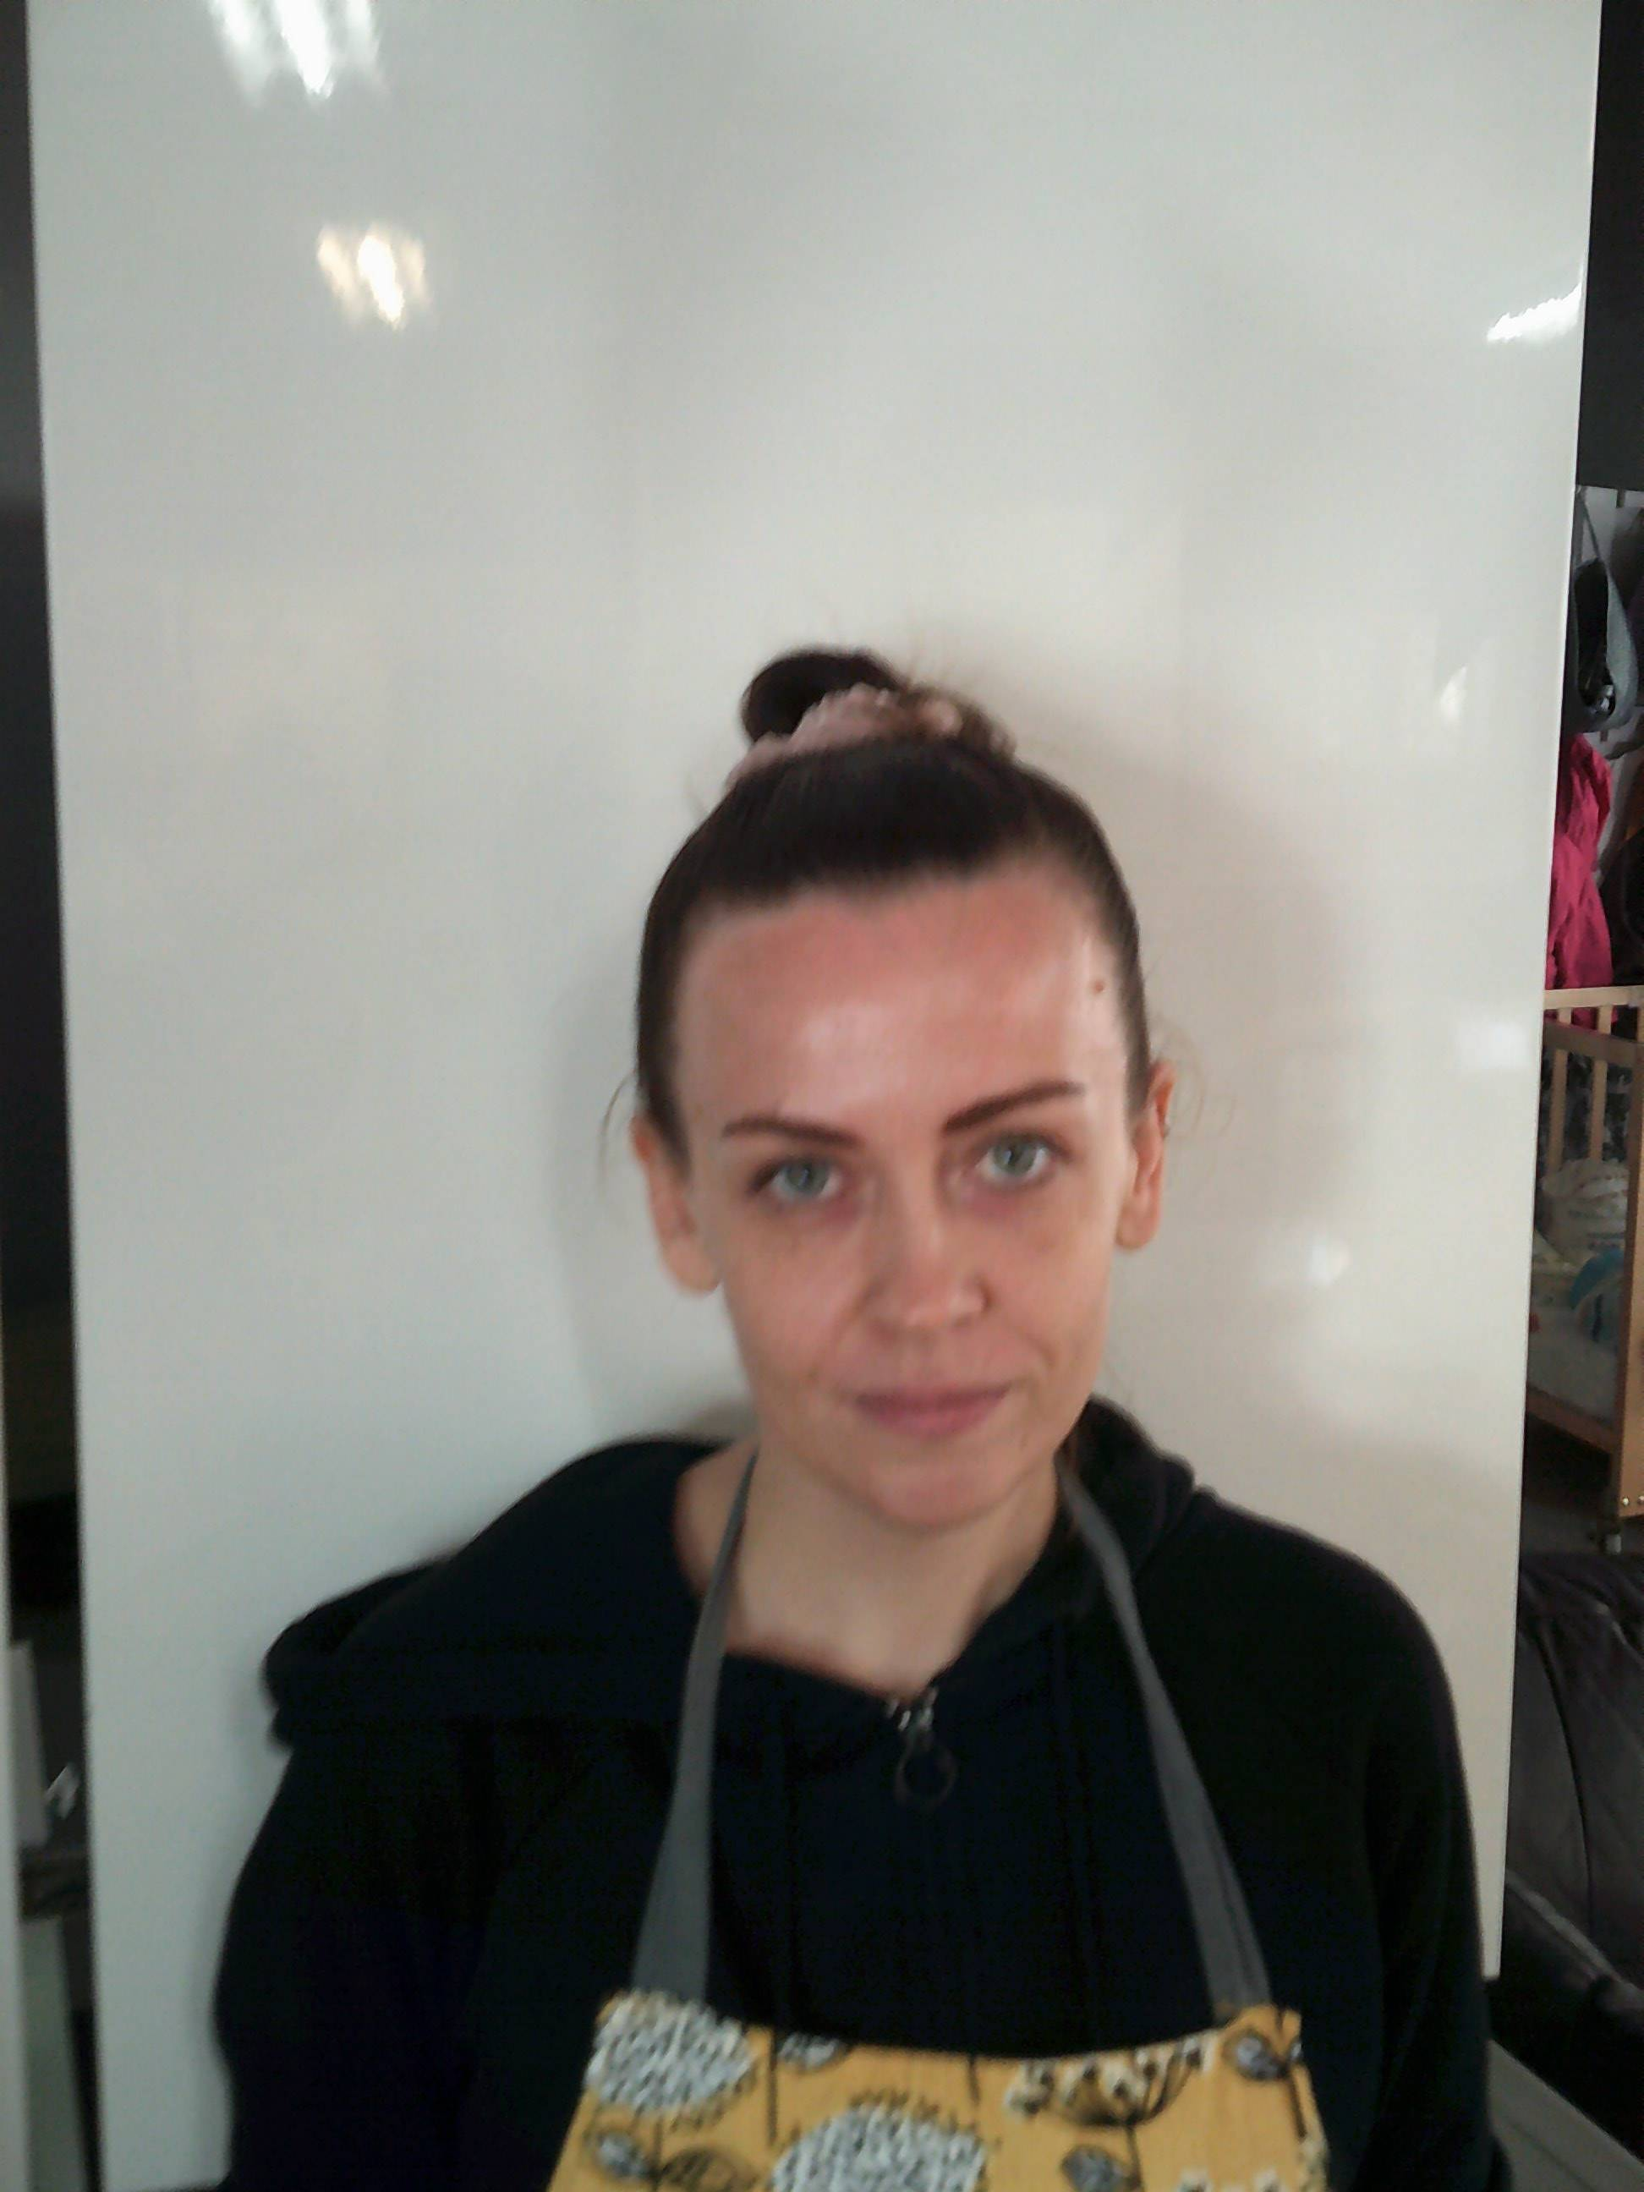
Erika Hamedi

