

Caterpillar’s welcome to our room

Our aim is to provide a warm and caring environment where the children in our care feel confident in taking risks in a safe manner, build up their independence and form relationships with their peers and a key-person from within the room.

Caterpillar’s room has a team of 3 or 4 staff, depending on numbers and occasionally with help from students. Additional staff come in over the lunch period to ensure staff ratios are met and encourage the children to eat, using a knife and fork (depending on their level of development).

We have a ratio of 1 adult to 4 for two to three year olds.

We have direct access from the room onto two garden areas; this allows for free flow play to the outside learning environment. We also use the much larger garden for when the children need to burn off excess energy!

We encourage parents to help settle children by having brief visits with their child, gradually leaving them for longer periods, please speak with a member of staff and discuss your needs or if you have any concerns.

As the main educator and carer of your child please share any comments you think may be of help regarding your child, this enables us to provide your child’s individual needs. Observations are taken by your child’s key-person and are available for you to share, please speak to your key-person.

When you feel your child is ready to come out of nappies and are ready to start using the toilet staff will support your child with this. Ideally, we aim for this before they move up into Butterflies room, as we have no nappy changing facilities in this room, but if you any have concerns speak to your key-person.
Children move up to Butterflies room when they are three, or if possible when it suits their individual needs, this maybe earlier or a little later. A month prior to moving up they will be taken for visits so they can settle into their new environment more easily, forming new bonds and friendships. We will introduce you to the new key-person and share the routine of the room, so you can ask questions and get to know the new team.

Below is a guide of the room’s routine however we do cater to the routine of each individual child especially with regards to their sleep and feed patterns.

Basic routine:

Morning snack/breakfast is offered to the children by a snack bar system, where the children are able to choose what they would like from a small selection of healthy snacks which we provide. We encourage children to become independent, helping themselves to fruit or toast etc.

Cow’s milk is offered with morning and afternoon breaks.

Lunch is served at 12.30; however if children are sleeping we will keep lunch for them until they are ready.
Mid-afternoon snack is served at 3.30pm

Nappy changes are at least three times a day
(Or as and when needed by key person wherever possible)

Things to remember to bring in for your child:

- Cup or bottle for water that can stay here

- Nappies – Wipes - Nappy cream – Sun-cream & Sun Hat in warmer weather – Wellingtons & outdoor rain coat
- Spare pants/knickers if toilet training - Change of clothes – Comforters

- Photo of child and parents/carers, these are used to display in the room so that the child can see them

- Medications for temperature (Paracetamol/ Ibuprofen)

Please label any items clearly as it saves confusion at end of the day.

Feel free to talk to staff within the room whenever you have any questions or queries, or if you have any suggestions/ideas you may wish to pass on to us.

Staff Photo Page

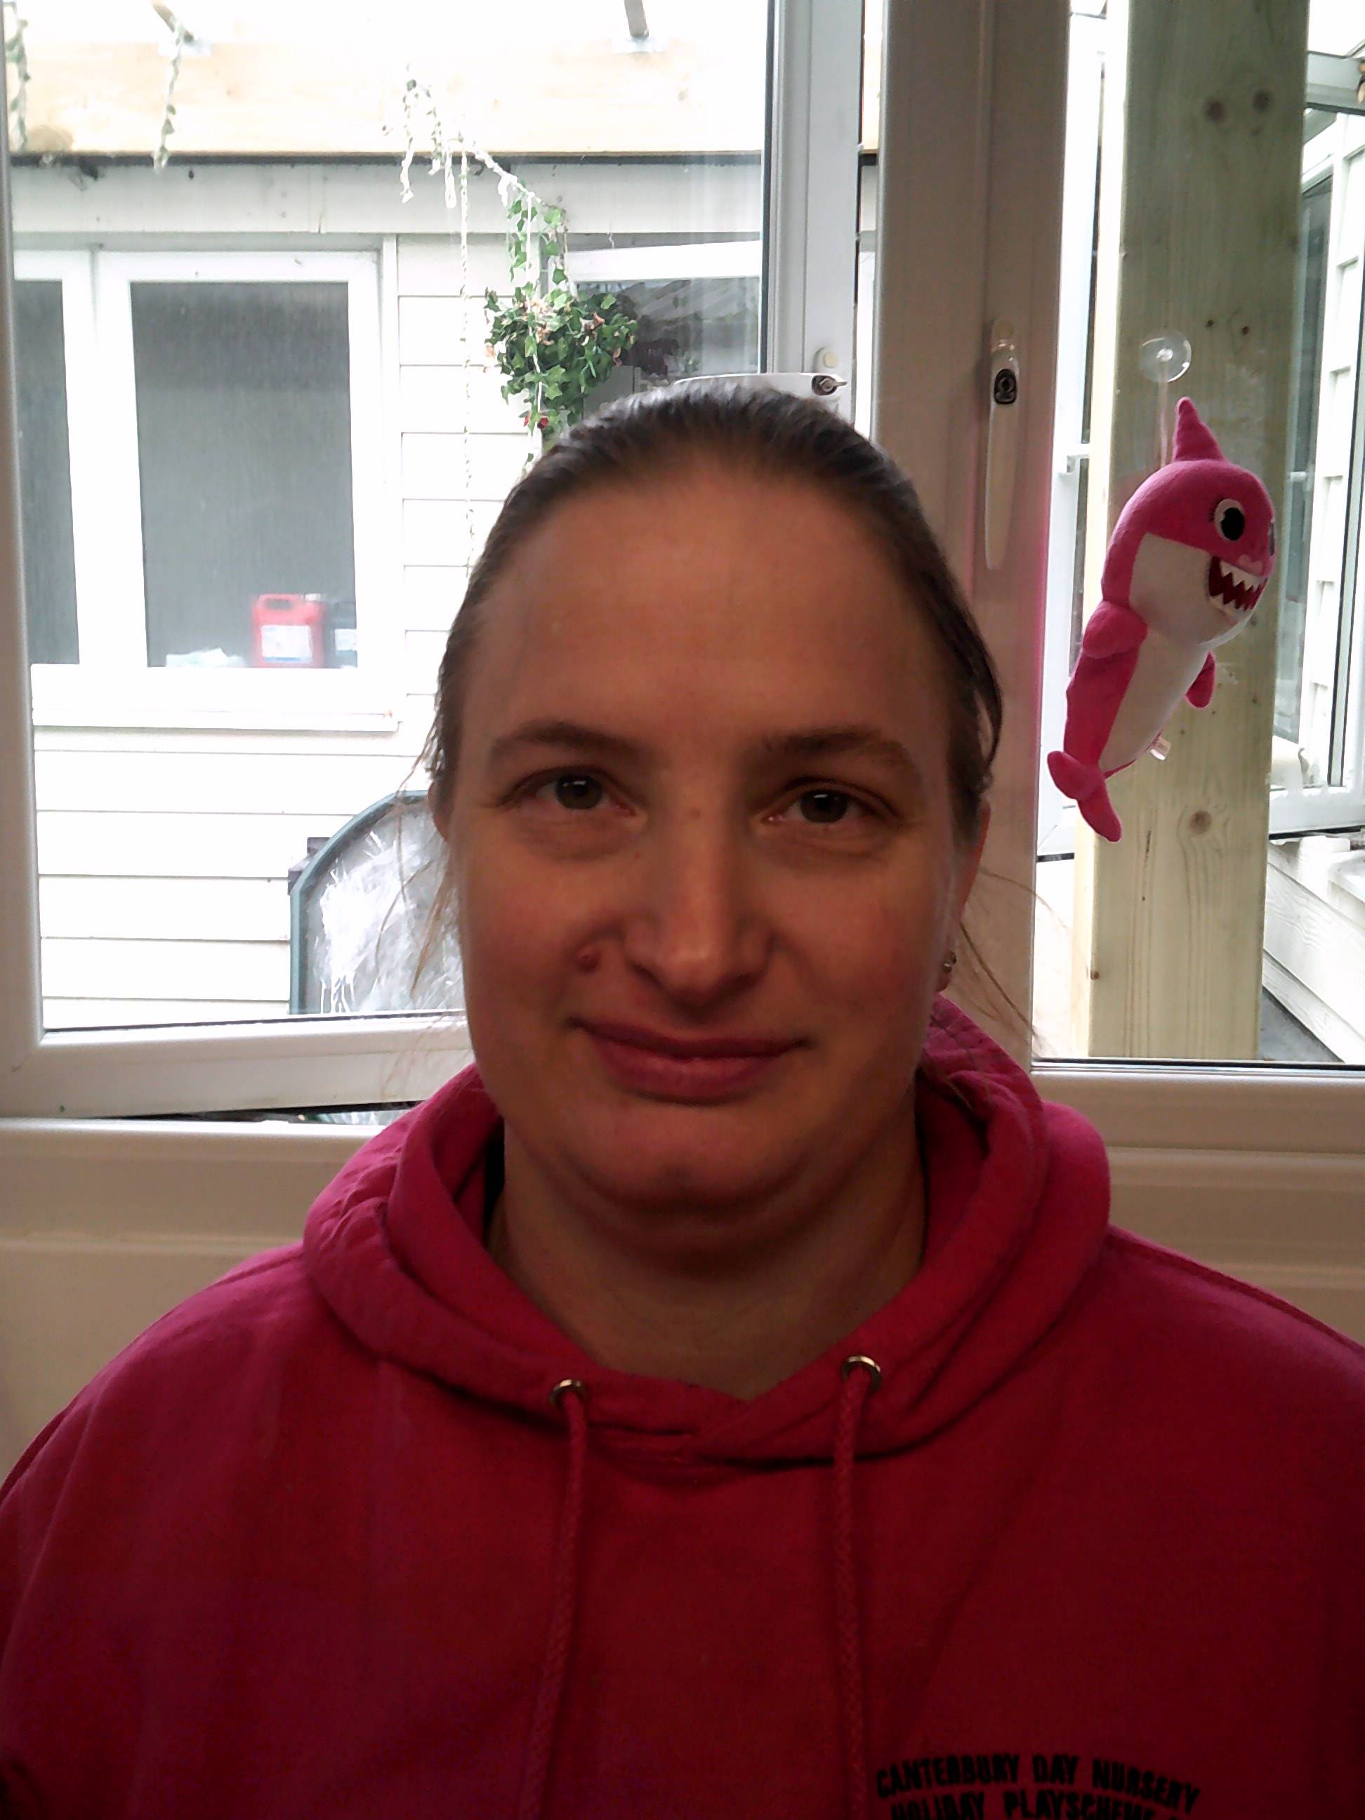
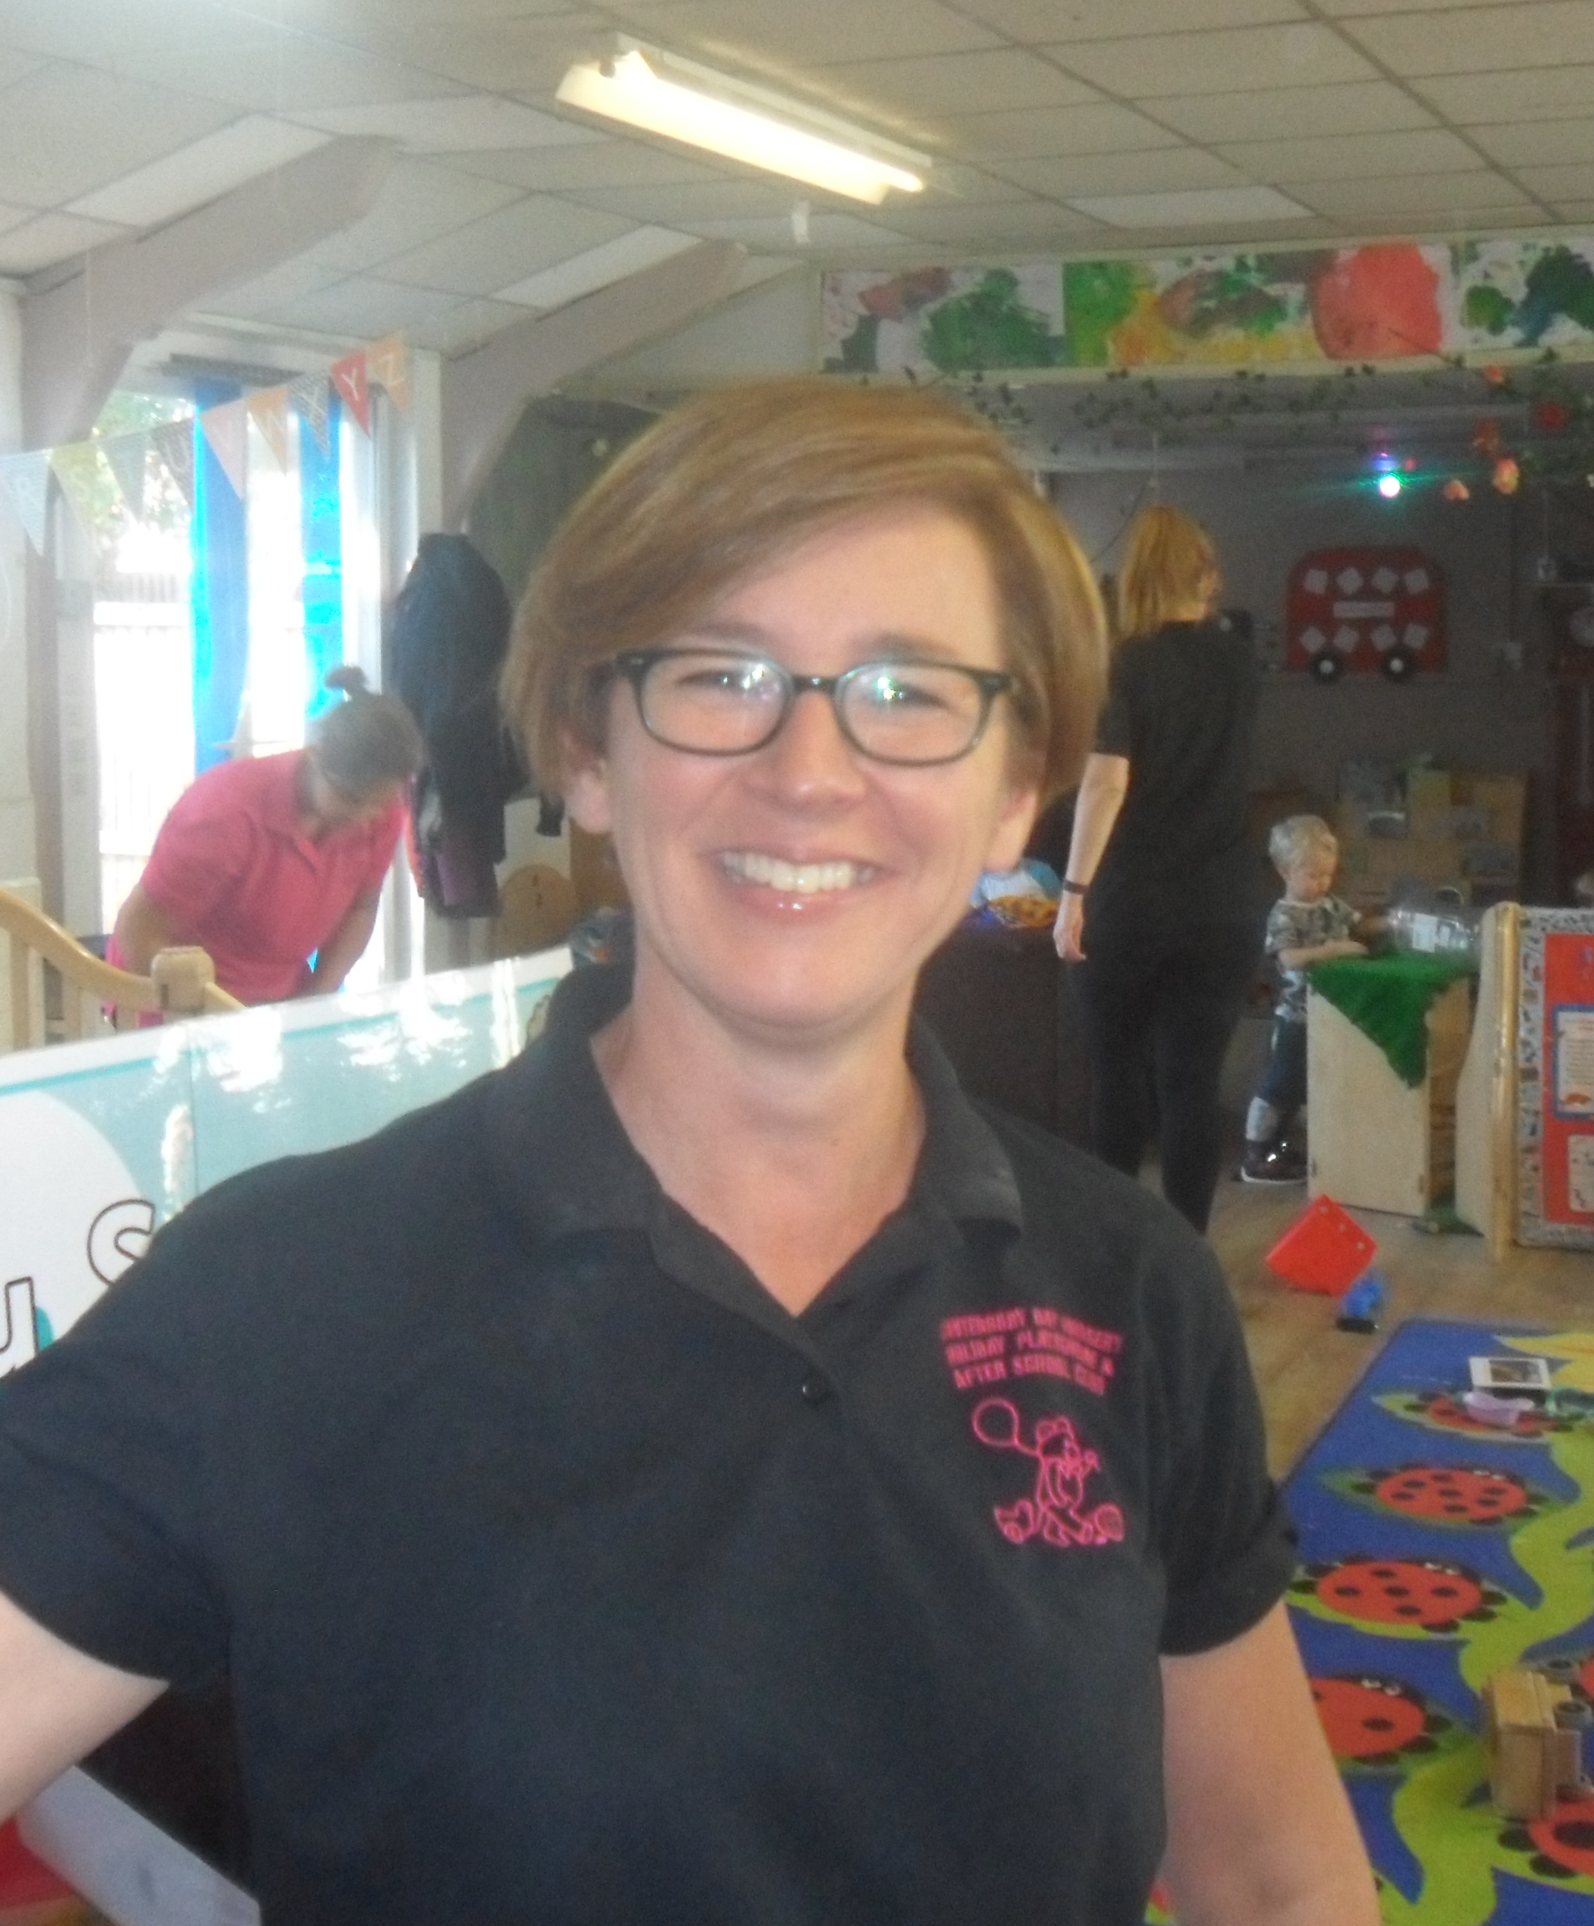
Senior Early Years Practitioner Deputy Early Years Practitioner
Emma Wakeman
First Aider Katrina Neilly
First Aider
Early Years Practitioners

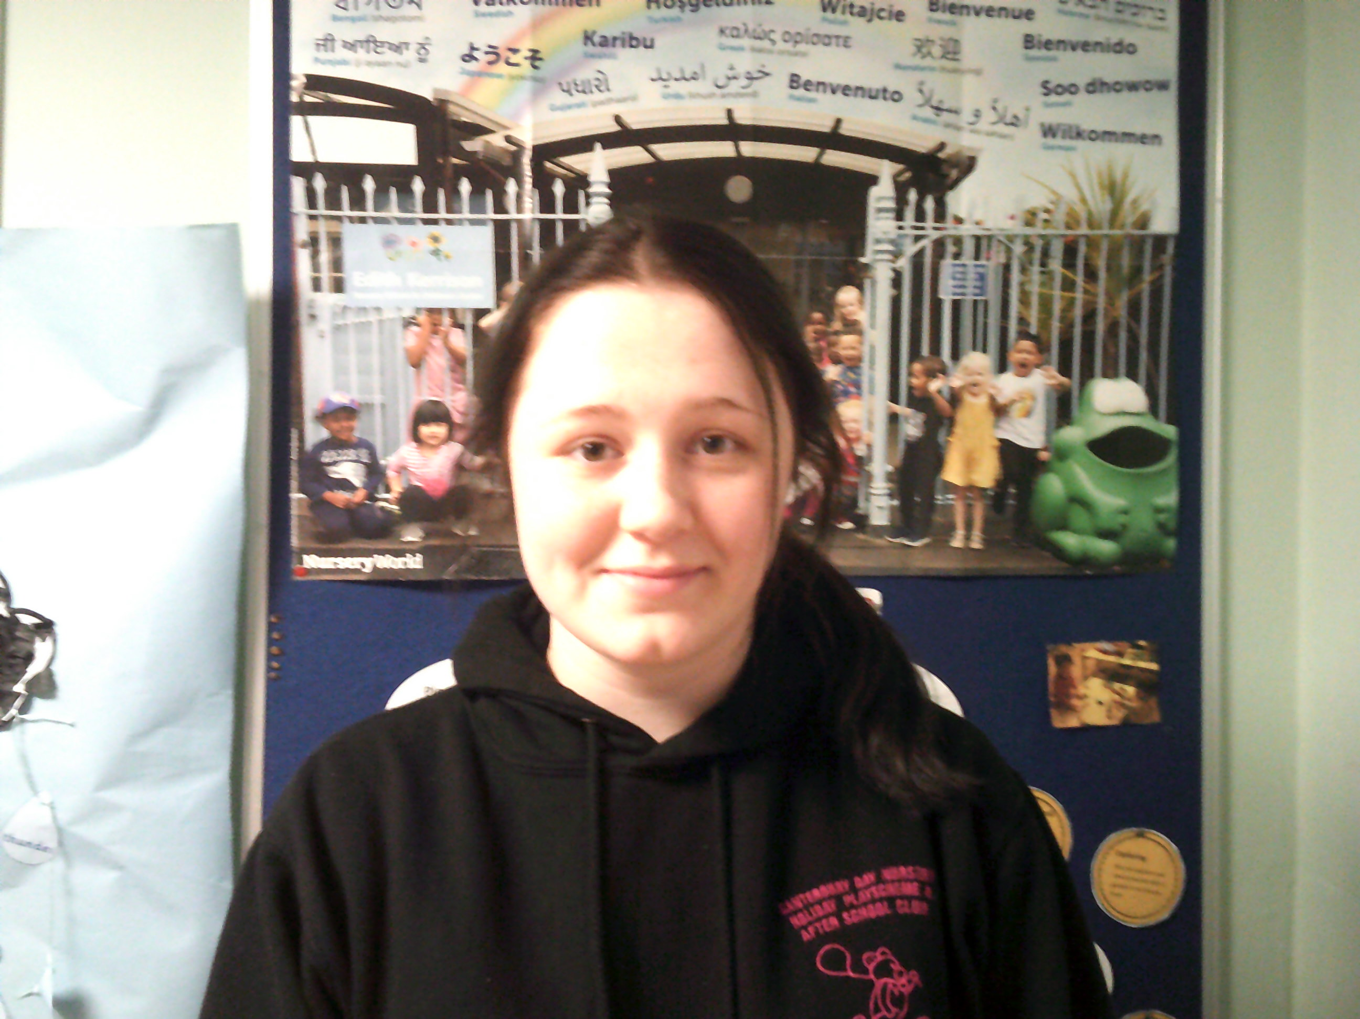
Millie Needham

Nicola Hills Lunchtime Assistant

Early Years Practitioners Cover Staff
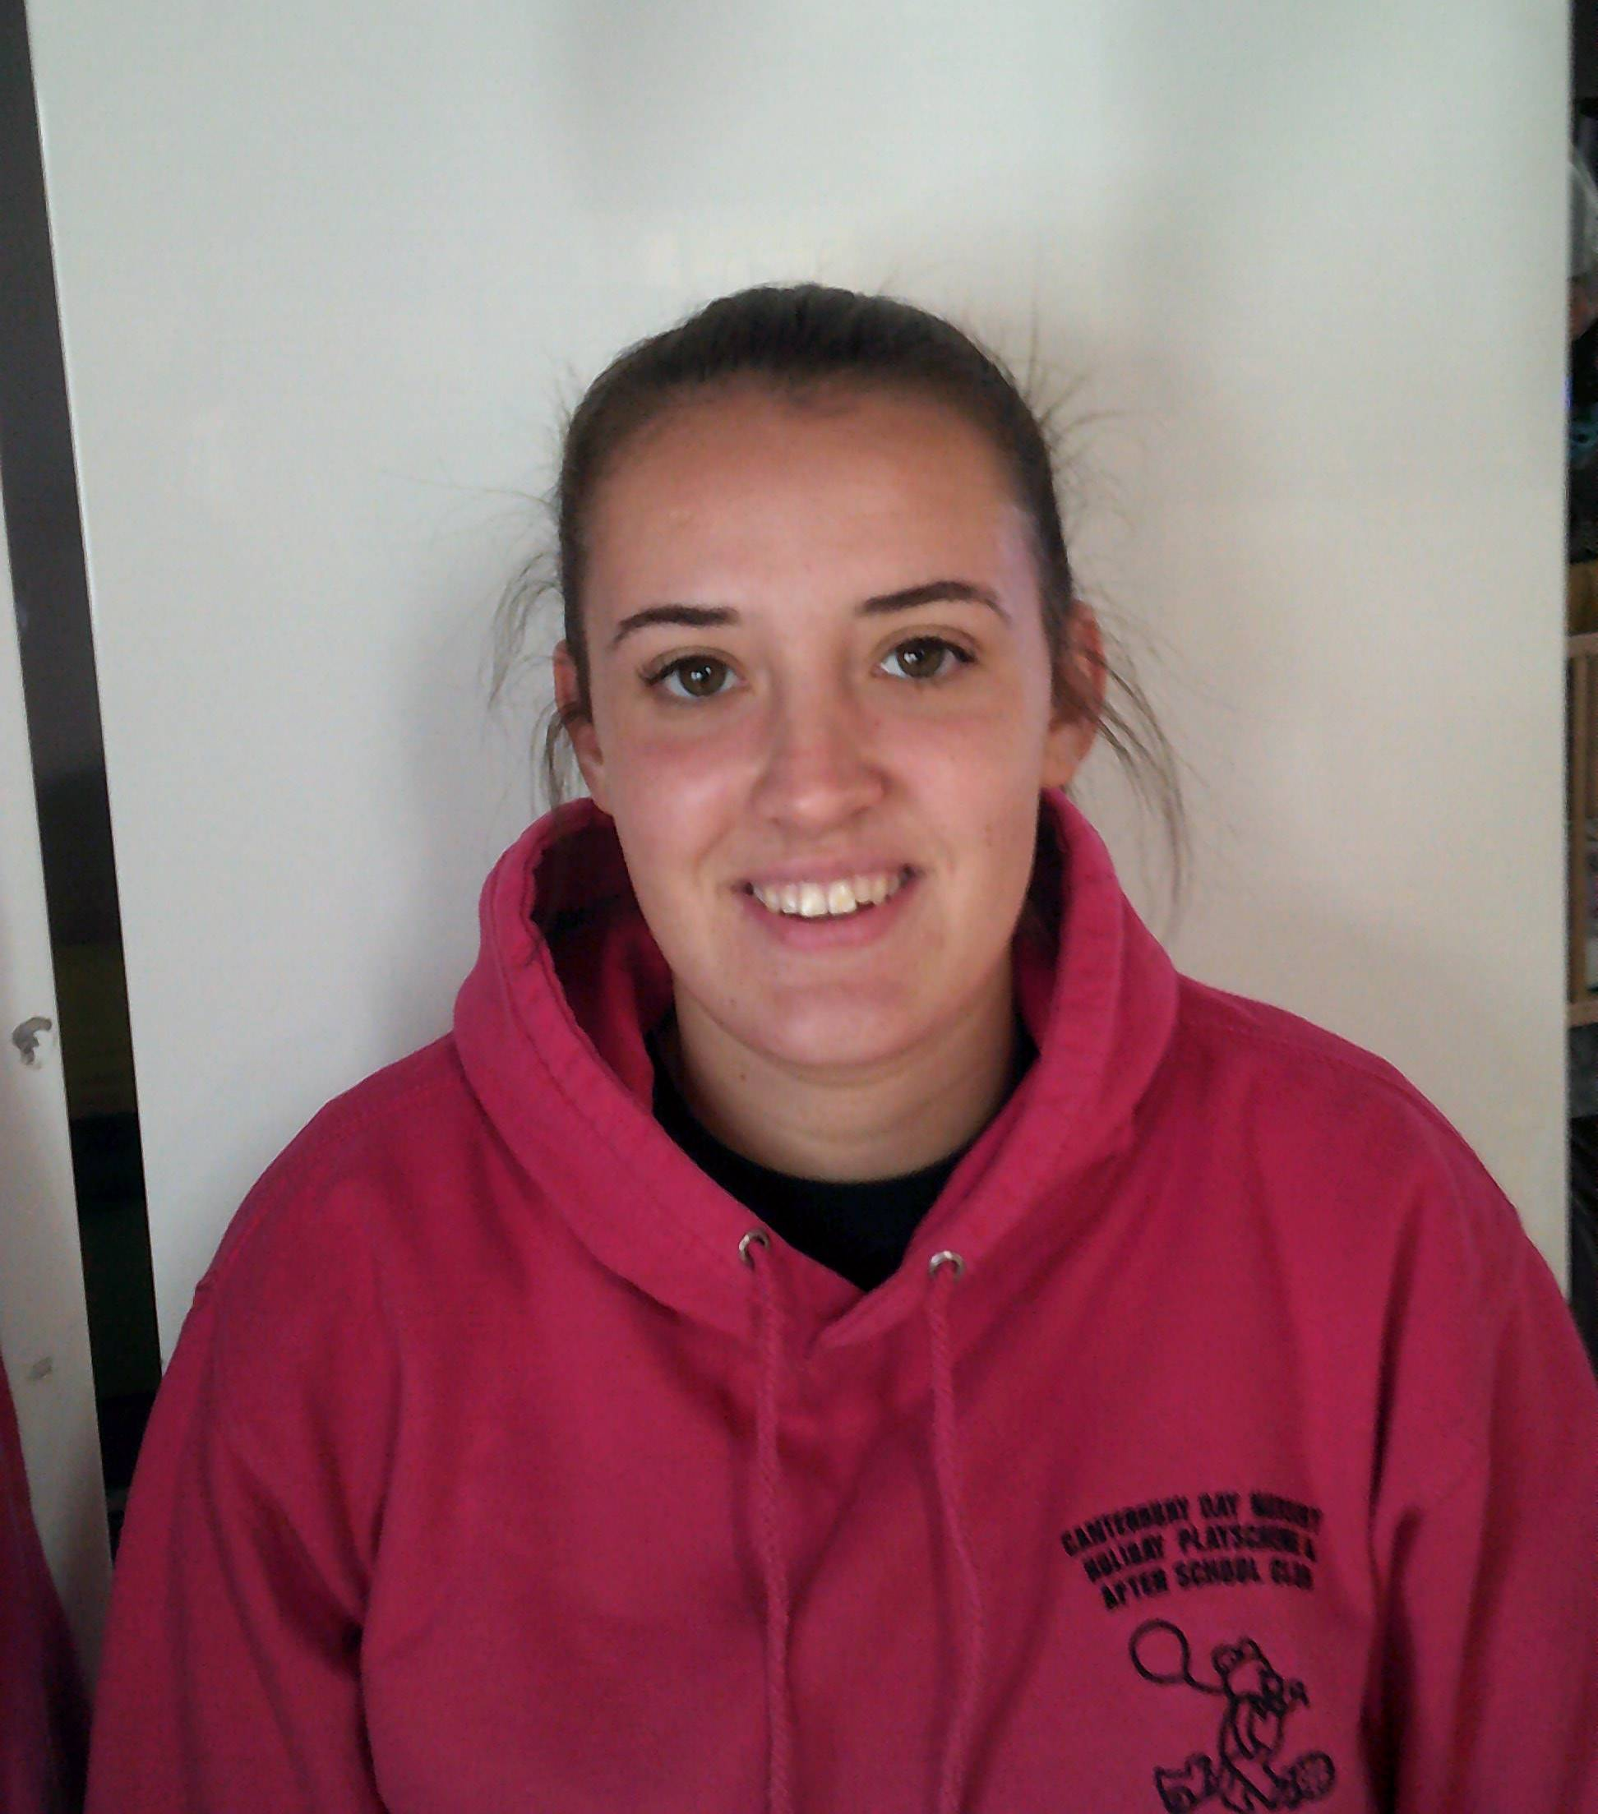
Megan Pearce
First Aider Corina Jones
First Aider

